National School Safety Leadership and Technology Summit

December 4 – 7, 2022 Tempe, AZ

Presented by:
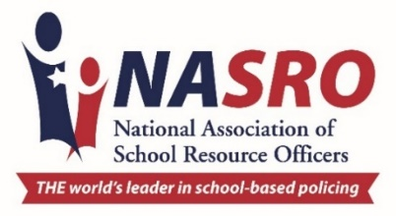
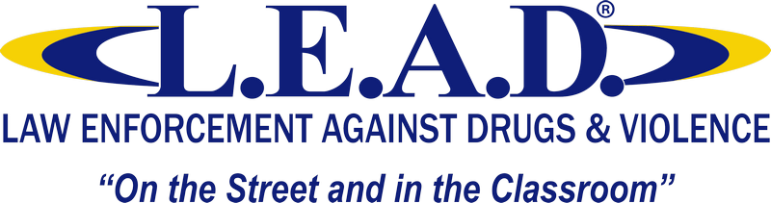

Welcome to the NASRO National School Safety Leadership and Technology Summit! All events will be held in the Opal Ballroom unless otherwise noted. If you need any assistance while you are here, please see a NASRO team member.

Sunday, December 4th

4:00 – 6:00 pm |  | Attendee Registration Hotel Lobby
6:00 – 8:00 pm |  | Welcome Reception  Sponsored by Safe Hiring Solutions Skysill Rooftop Lounge

Monday, December 5th

7:00 – 8:30 am |  | Attendee Registration Opal Ballroom Foyer
7:15 – 8:15 am |  | Breakfast (provided) Sunstone Terrace
8:30 – 8:45 am |  | Welcome and Opening Remarks
8:45 – 9:30 am |  | School Safety Strategies and SRO Programs  Mo Canady, NASRO Executive Director
9:30 – 10:00 am |  | Guiding Principles for School Resource Officers: A overview of Federal Resources Available for School-based Law Enforcement and Communities  Rob Chapman, Acting Director, COPS Office
10:00 – 10:15 am |  | Break
10:15 am – 11:30 am |  | Imagery & Exploitation: Survivor Insights on Sextortion and How Professionals Can Help  Kathryn Rifenbark, Program Manager, Survivor Services, National Center for Missing and Exploited Children  Taylor, Survivor Advocate
11:30 am – 12:30 pm |  | Lunch (provided) Sunstone Terrace
12:30 – 1:30 pm |  | Engaging State Legislators in School Safety and School-Based Policing  Paul DeMarco, Attorney and Former Alabama State Representative
1:30 – 4:30 pm |  | The Duty to Protect Students: The Incoming Storm of School Liability  Bernie James, Professor of Law at Pepperdine University  Opal Ballroom
4:30 – 6:00 pm |  | Reception  Sponsored by Safer Watch Sunstone Terrace

Tuesday, December 6th

7:15 – 8:15 am |  | Breakfast (provided)  Sunstone Terrace
8:30 – 10:30 am |  | U.S. Secret Service Research, Analysis and Key Findings of Averted and Targeted School Violence  Dr. Lina Alathari, Chief, National Threat Assessment Center · U.S. Secret Service  Opal Ballroom
10:30 – 11:30 AM |  | L.E.A.D. Opal Ballroom
11:30 am – 12:30 pm |  | Lunch (provided) Sunstone Terrace
12:30 – 2:30 pm |  | Your Brain on Electronics  Dr. Christy Kane, PsyD, CMHC, LPC Opal Ballroom
2:30 – 2:45 pm |  | Break
2:45 – 4:30 pm |  | Supporting the Mission of Law Enforcement in an Education Based Environment  Lt. Rudy Perez, Los Angeles Schools Police Department  Opal Ballroom

Wednesday, December 7th

7:15 – 8:15 am |  | Breakfast (provided)  Sunstone Terrace
8:30 – 11:30 am |  | Digital Threat Assessment® - The Early Identification of Digital Leakage  Dr. Greg Gerber, Safter Schools Together  Opal Ballroom
11:30 am – 12:00 pm |  | Closing Remarks  Mo Canady, NASRO Executive Director  Opal Ballroom

P 

