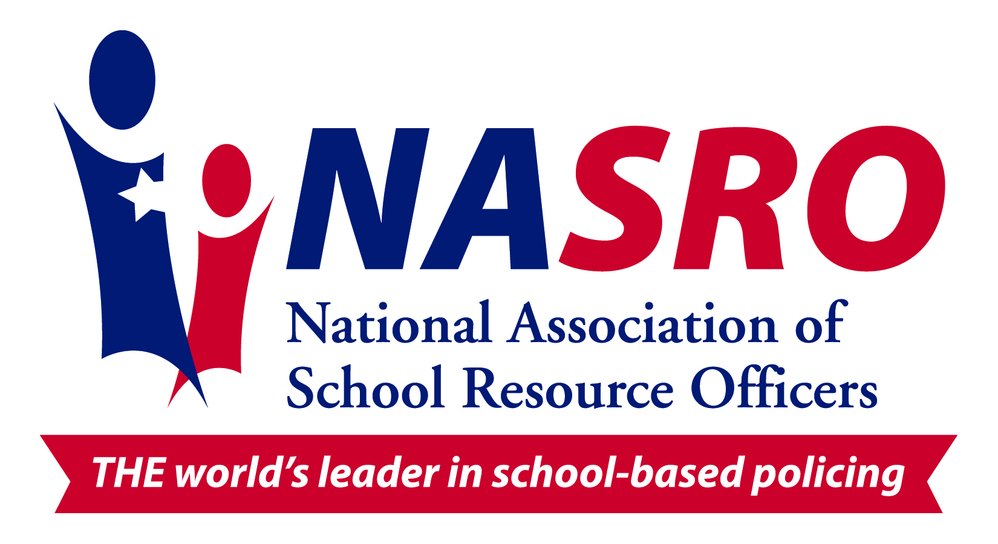

Safer schools, safer kids...

Julie Quesenbury
NASRO Instructor
jquesenbery@columbus.in.gov

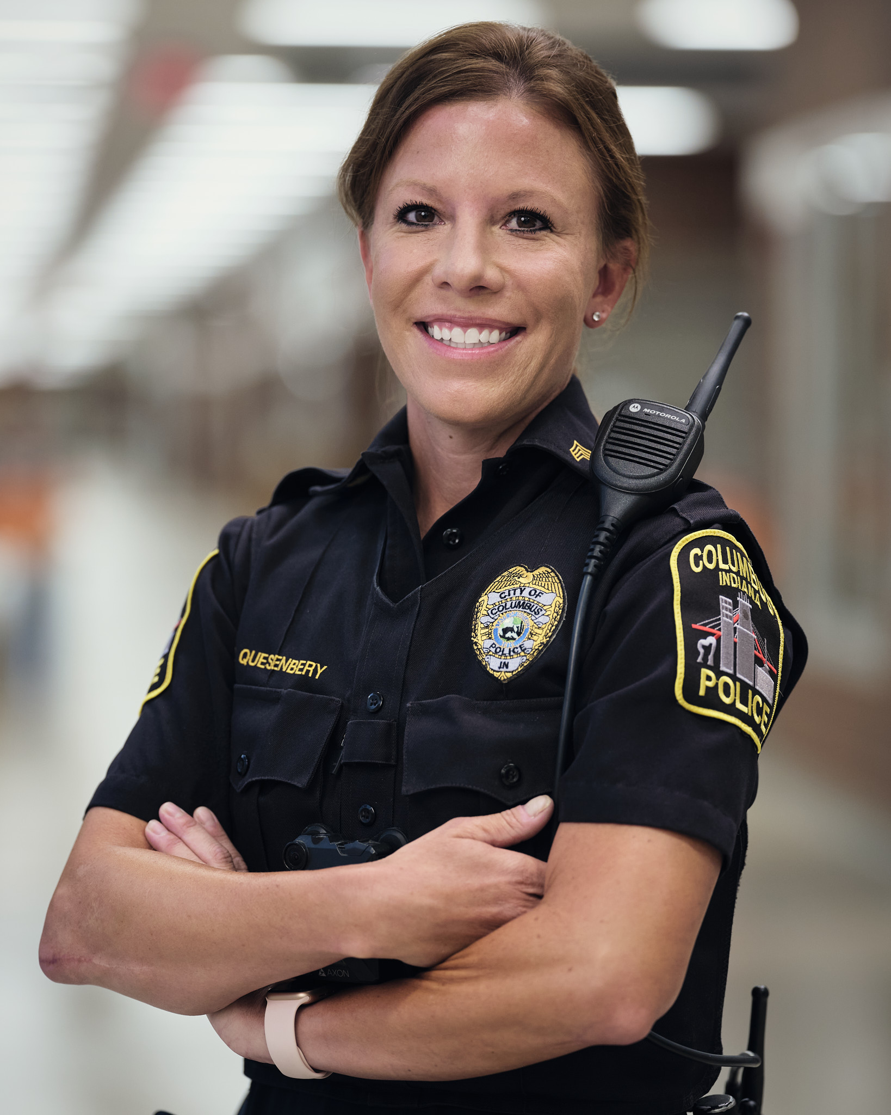
Julie Quesenbery is a police officer at the Columbus, Indiana, Police Department. During her 18 years at CPD, she has served as a field training officer, D.A.R.E. instructor, cadet coordinator, and physical tactics instructor. Currently, she serves as the sergeant for the school resource officer (SRO) division, which includes officers from the Columbus Police Department and the Bartholomew County Sheriff’s Office.

As an SRO, Julie has co-developed corporation-wide emergency procedures and she regularly trains school staff, students and community members. In addition, she co-authored a young women’s self-defense class called, “SAFE” (Situational Awareness for Everyday). To date, over 2,000 young women have taken part in the program. In March of 2020, this program was extended to young men for the first time and is called, “SAFE - The Dude Version”. Most recently, the programs were made available to officers across the nation to use in their own buildings by using the website, “srosafe.com.”

In 2017, Julie began serving in the capacity of 2nd Vice President for the Indiana School Resource Officers Association (INSROA). Since then, she served 3 years as 1st Vice President where she pioneered the INSROA Accreditation Program. In June of 2022, Julie began proudly serving as President of INSROA.
Julie is a National Association of School Resource Officers (NASRO) Instructor, and a large portion of her career has been dedicated to efforts in bridging the gap between law enforcement and youth. Julie holds an Associate of Science in law enforcement from Vincennes University and a Bachelor of Science in criminology from Indiana State University.

She has a 10-year-old son, Wyatt, and a 13-year-old daughter, Halle. In her free time, Julie enjoys fishing, long endurance sports and is an Ironman triathlete.

