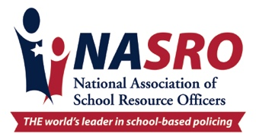

Safer schools, safer kids...

SRO TIM DOLL
Billings Police Department/Billings Public Schools SD#2
dolltj@billingsschools.org
Officer Tim Doll currently serves as a School Resource Officer (SRO) with the Billings Police Department. He brings over 23 years of law enforcement experience, having served in both Billings, Montana, and Casper, Wyoming. Throughout his career, Officer Doll has held a variety of roles including Patrol Officer, Detective, Crime Scene Investigator, and Academy Instructor.
For the past nine years, Officer Doll has been dedicated to school-based policing. He has spent six years as an SRO at the high school level and is currently assigned for the past three years in a middle school. In addition, he has supported several elementary/charter/alternative schools in an SRO capacity. Officer Doll has been recognized by the National Association of School Resource Officers (NASRO) as a Practitioner by focusing on school-based policing standards and training.
Officer Doll is the NASRO Board of Directors as the Region 10 Director overseeing MT, ID, WY, UT and CO. He also serves as President of the Montana Association of School Resource Officers (MTASRO).
His extensive background has included numerous specialized assignments and collateral duties such as:
- Polygraph Examiner
- Arson Investigator
- Crisis Intervention Team (CIT) Instructor
- Field Training Officer
- Firearms Instructor
- Hostage Negotiator
- Active Shooter Response Instructor (Law Enforcement)
- Armed Intruder Response Instructor (School Staff)
- Honor Guard Team Member
Officer Doll is also actively involved in youth leadership initiatives, including the Montana Junior Police Leadership Academy, Camp BLUE (Building Leadership, Unity, and Ethics), and previously with Camp Postcard (Police Officers Striving to Create and Reenforce Dreams).
He holds a Bachelor of Science degree in Sociology with a concentration in Criminal Justice from Montana State University–Billings.

