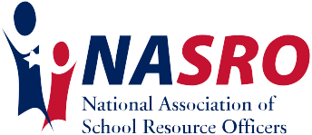

Safer schools, safer kids...

Seth Sullivan
NASRO Instructor and 2nd Vice President
Seth.Sullivan@nasro.org

Seth Sullivan currently works as a school resource officer for the Cullman Police Department in Cullman, Alabama. He began his public safety career in 1993, and he attended the Northeast Alabama Police Academy in 1995. Over the years, Seth has worked in dispatch, patrol, as shift supervisor, the traffic homicide unit, bike patrol unit, community relations, and as public information officer.

A NASRO national instructor since 2014, Seth teaches the Basic SRO, Advanced SRO, Crime Prevention Through Environmental Design and the Adolescent Mental Health Training courses. He has been involved with The Alabama Association of School Resource Officers (TAASRO) for several years as the Education Coordinator, and he is currently the Vice President. Seth enjoys teaching for NASRO and has had the opportunity to train several thousand officers over the years, receiving great evaluations from his trainees.

Seth also serves on Board of Directors for NASRO as the 2nd Vice President. In 2020, he was appointed as a School Safety Specialist for the Alabama State Department of Education on the ALSDE School Safety Task Force. He was appointed by the Florida Association of School Resource Officers Board of Directors in 2022 to serve as the NASRO liaison on their board.

2020 Valleydale Road, Ste. 207A Hoover, AL 35244 1.888.316.2776 www.nasro.org

