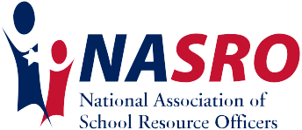

Safer schools, safer kids...

Beth J. Sanborn, DPA
bethjsanborn@gmail.com

Dr. Beth J. Sanborn is a nationally recognized school safety expert, speaker, author, and advocate dedicated to strengthening the relationship between schools, students, and law enforcement. A retired police officer and former School Resource Officer and juvenile detective, Beth brings more than two decades of real-world experience working at the intersection of education, public safety, and youth development.
She currently serves as School Safety Coordinator for Montgomery County, Pennsylvania, where she is responsible for school safety planning, training, and coordination across 22 public school districts and approximately 435 schools. In this role, Beth leads countywide initiatives focused on prevention, preparedness, and collaboration among educators, public safety professionals, and community partners. She also serves as President of the Pennsylvania Association of School Resource Officers.
Beth is the creator of the nationally delivered Hidden, High, & Hammered program, an interactive and eye-opening educational experience focused on youth substance use, vaping, and decision-making. She is the author of The Missing Piece: Your School Resource Officer as an Ally in Parenting and Piecing It Together: School Resource Officers as Allies in Education, both of which emphasize the power of proactive relationships, trust-building, and meaningful engagement in school communities.
A TEDx speaker, Beth regularly presents at national and international conferences and has testified before the Pennsylvania House Education and Health Committees on school safety and youth-related issues. Known for her engaging, relatable style and deep respect for student rights, her work is grounded in one core belief. When adults in schools work together with intention and empathy, safety and connection follow.

2020 Valleydale Road, Ste. 207A Hoover, AL 35244 1.888.316.2776 www.nasro.org

