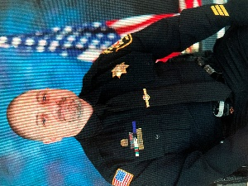 MANNY FARDELLA 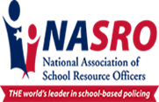

Manny began his law enforcement career in 2001, serving in his home State of New Hampshire. He worked for a small agency and served in the capacity of patrol officer and juvenile officer. Additionally, he was responsible for coordinating background investigations on new hires, as well as conducting physical fitness agility testing for all officers to meet NHPSTC Standards.
In April of 2008, Manny relocated to Cheyenne, Wyoming to begin a new position with the Cheyenne, Wyoming Police Department. Manny’s career in Cheyenne began in patrol, and he also served as a crime scene technician and squad leader. In 2011, he transferred into the School Resource Officer specialty assignment. Manny served as an SRO at Johnson Junior High School in Cheyenne from 2011-2016 and then transferred to Cheyenne South High School in April of 2016. Manny serves as the co-chair of the South High School Emergency Management Team and is often asked to speak with various stakeholders throughout the school district, including parents, faculty, and community members.
Manny obtained his NASRO Practitioner in 2014 and has been actively involved with the National Association of School Resource Officers (NASRO). He has been to several NASRO conferences and became a NASRO Instructor in 2015. Manny served as the Conference Chairman for the WYSROA State Conference in 2016, and He served as the WYSROA Vice President from 2014-2016. In April of 2016, Manny assumed the duties as President of WYSROA, a position he held until 2021.
In 2021, Manny served as a special guest to serve on a panel of presenters for the National Well-beings Tour in Casper, Wyoming. Panelists presented information on adolescent mental health and social media trends in the digital world. Throughout Manny’s career, he has been requested to train SRO’s and school personnel in various components of school-based policing and best practices of school safety concepts. Manny has presented trainings independently, and for NASRO, across the United States for the last 10 years. Also in 2021, Manny was recommended by the Wyoming Board of Education to serve on a “Threat Assessment task Force” team for the State of Wyoming, with an objective to reduce school violence and provide access to mental health resources to students across Wyoming. With a focus on awareness and prevention methods, this three-year project was implemented statewide by the end of 2024. In 2023, Manny completed his National CPTED Designation Certification with the National Institute of Crime Prevention. He also serves on the Crime Prevention Team for Cheyenne PD.
Manny possesses a bachelor’s degree in criminal justice, with a concentration in Management, from the University of Phoenix. In October of 2021, Manny received his master’s degree in public administration at Columbia Southern University and joined the National Society of Leadership and Success CSU Chapter. For hobbies, Manny enjoys his Boston sports, traveling, and the outdoors.

