National School Safety and Security Summit

December 4 – 5, 2026 Phoenix, AZ
Presented by Safe and Sound Schools and the National Association of School Resource Officers

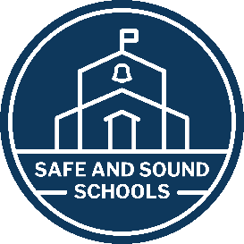
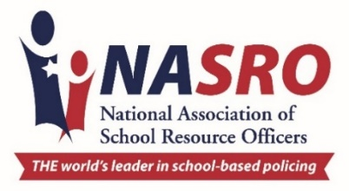

Thursday, December 3rd

3:00 – 5:00 PM |  | Registration  Location TBD

Friday, December 4th

8:30 AM |  | Opening Remarks  Mo Canady and Michele Gay Valley of the Sun ABC
8:45 AM |  | Perspectives in Prevention  Michele Gay, Molly Bradley Hudgens Valley of the Sun ABC
10:15 AM |  | Break
10:30 AM |  | Partners in Prevention Panel  Mo Canady, Ben Fernandez, Frank DeAngelis, Joe Hendry  Valley of the Sun ABC
11:30 AM |  | Lunch
12:30 PM |  | An Introduction to S.T.A.R. Training  Trevor Thrasher, High Threat Training Grou Location TBD
2:30 PM |  | Break
2:45 PM |  | Childhood 2.0  Katey McPherson Valley of the Sun ABC
4:00 PM |  | Closing Valley of the Sun ABC

Saturday, December 5th

8:30 AM |  | Evolving Landscape of School Safety & Security  Dr. Lina Althari, NTAC Valley of the Sun ABC
9:30 AM |  | Break
9:45 AM |  | General Session Valley of the Sun ABC
10:45 AM |  | Digital Threat Assessment  Steven MacDonald, Safer Schools Together Valley of the Sun ABC
12:00 PM |  | Lunch
1 PM |  | Digital For Good: Engaging Students as Leaders  Kim Karr Valley of the Sun ABC
2:00 PM |  | Break
2:15 PM |  | Digital & Cyber Security for Schools Antoinette King Valley of the Sun ABC
3:15 PM |  | Mental Health Matters  Dr. Amy Grosso Valley of the Sun ABC
4:15 PM |  | Closing

*This agenda is subject to change

P

